**TASK-1**

**Using a Loop Method**

**Source Code:**

fname = input("Enter the File Name:")

try:

    fhand=open(fname,'r')

    a = dict()

    for line in fhand:

        words = line.split()

        for word in words:

            if word in a:

                a[word] = a[word] + 1

            else:

                    a[word] = 1

    print(a)

except:

    print("File not found")

**Code Screenshots:**

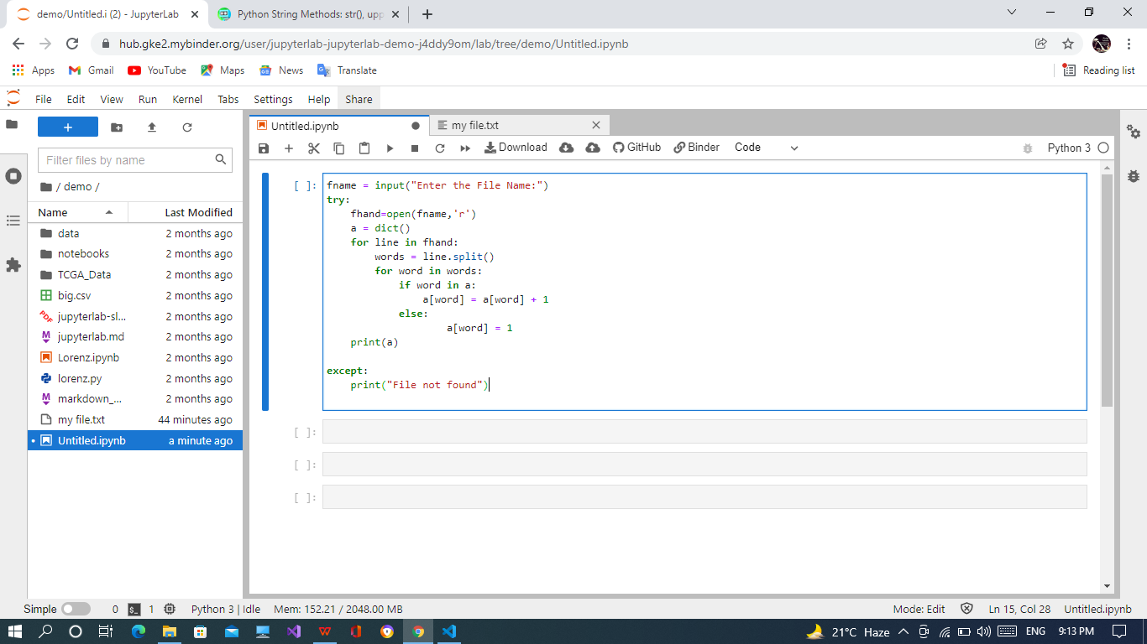

**Run Program:**

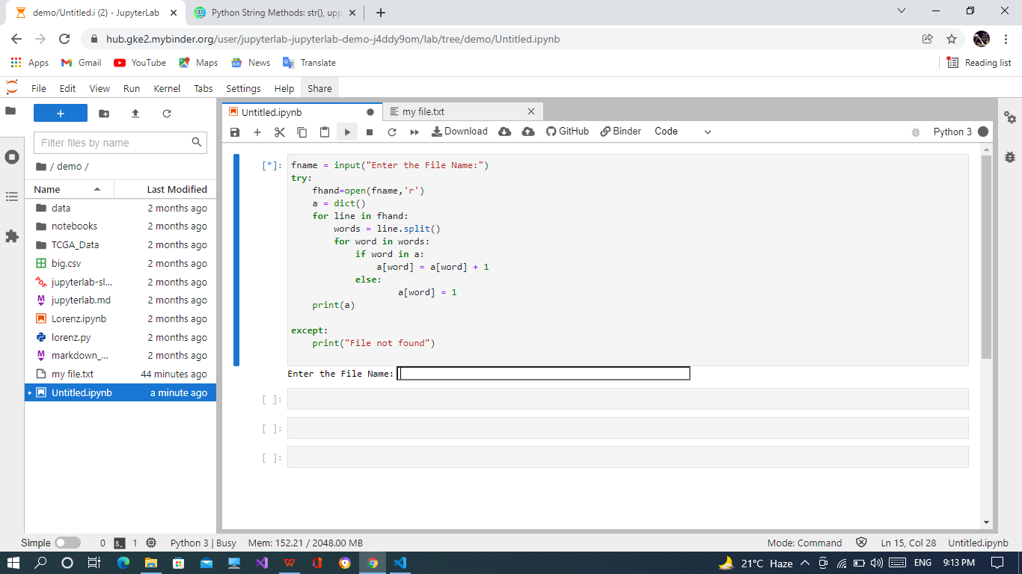

**Enter File Name:**

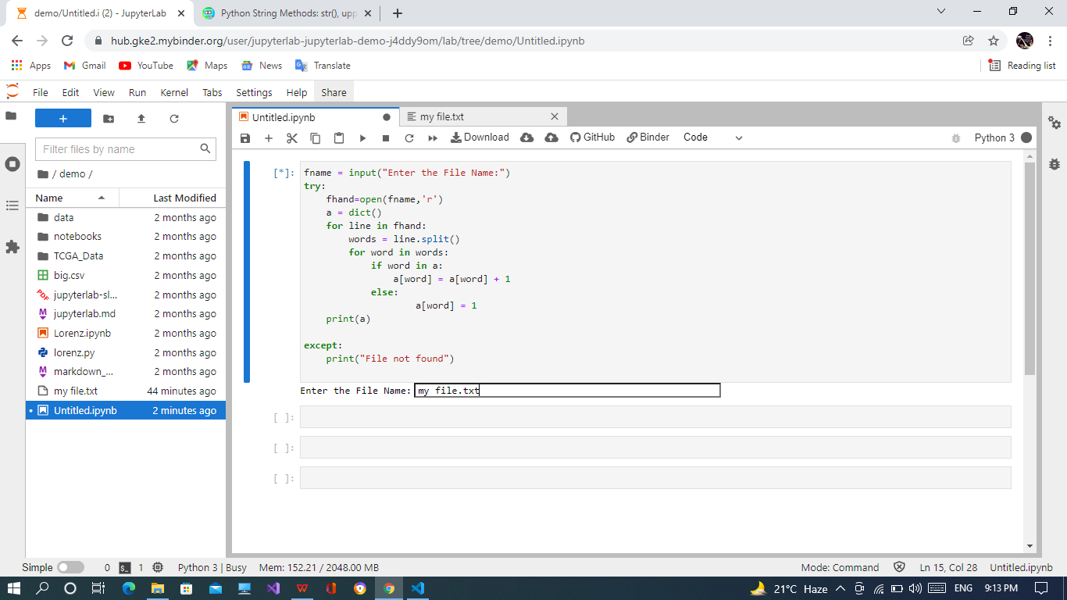

**Code Output:**

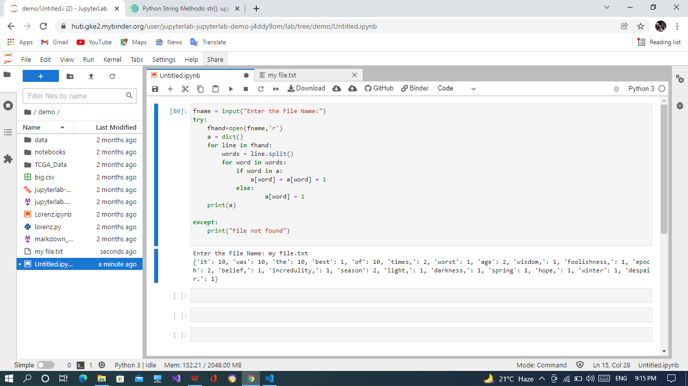

**Using a GET Function**

**Source Code:**

##Using Get Method

a = input("Enter the File Name:")

try:

    fhand = open(a)

    d1 = dict()

    for line in fhand:

        words = line.split()

        for word in words:

            d1[word] = d1.get(word, 0) + 1

    print(d1)

except:

    print("File not found")

**Code SS:**

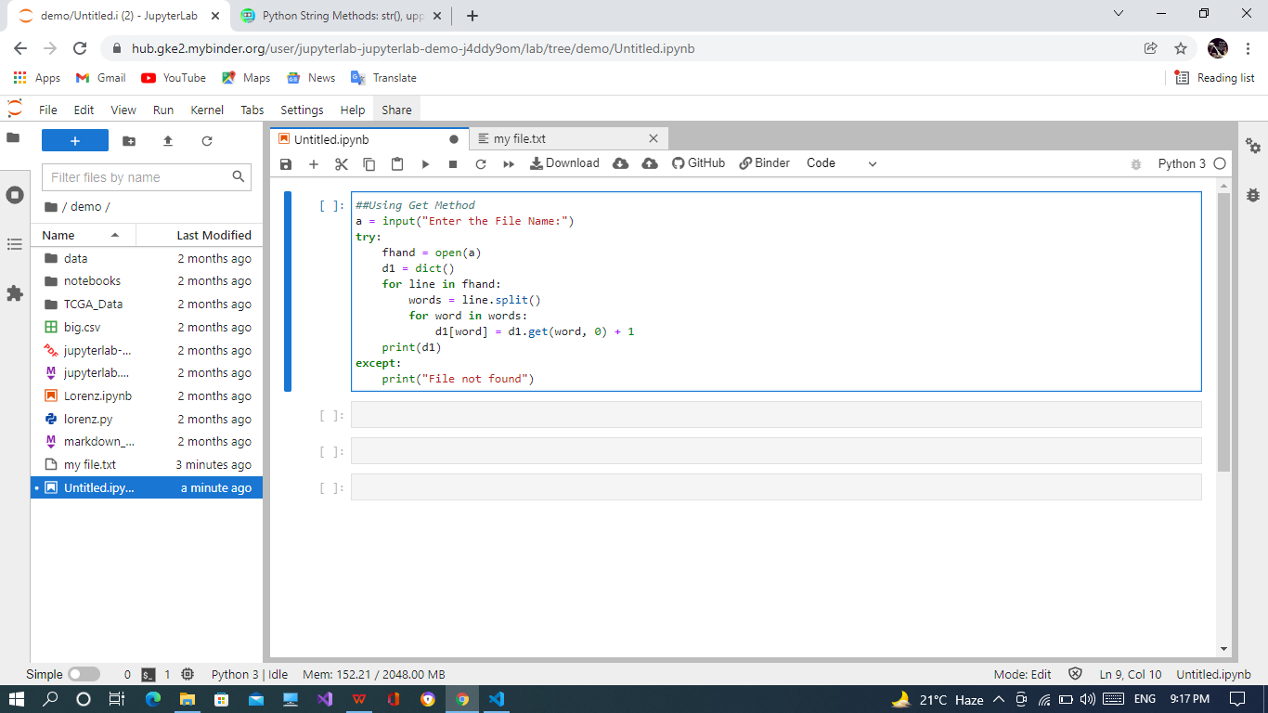

**Enter File Name:**

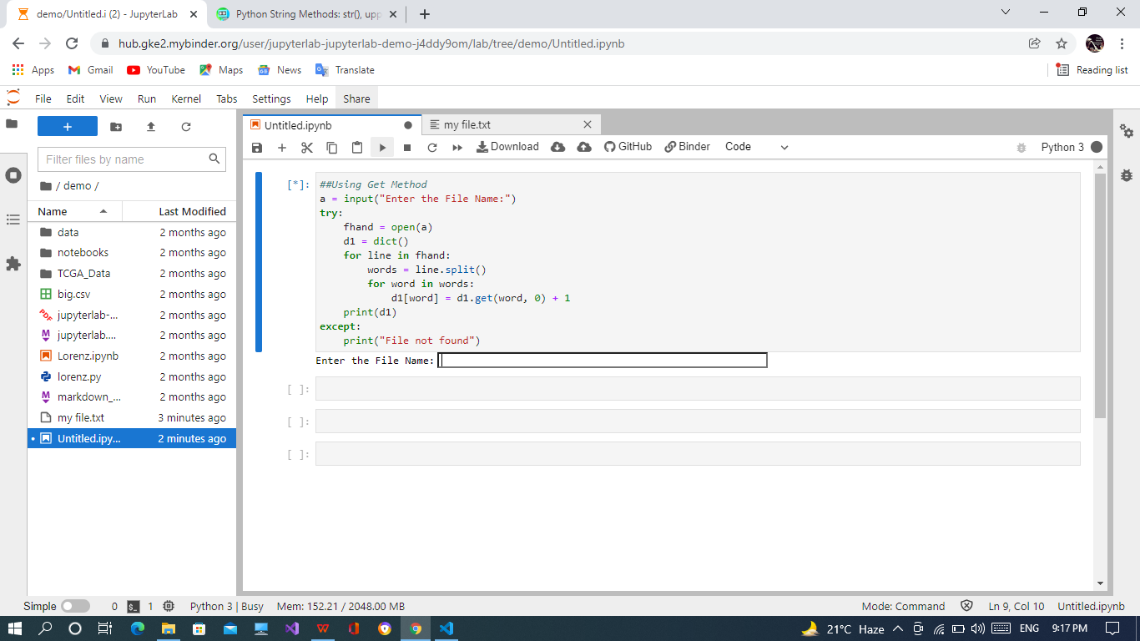

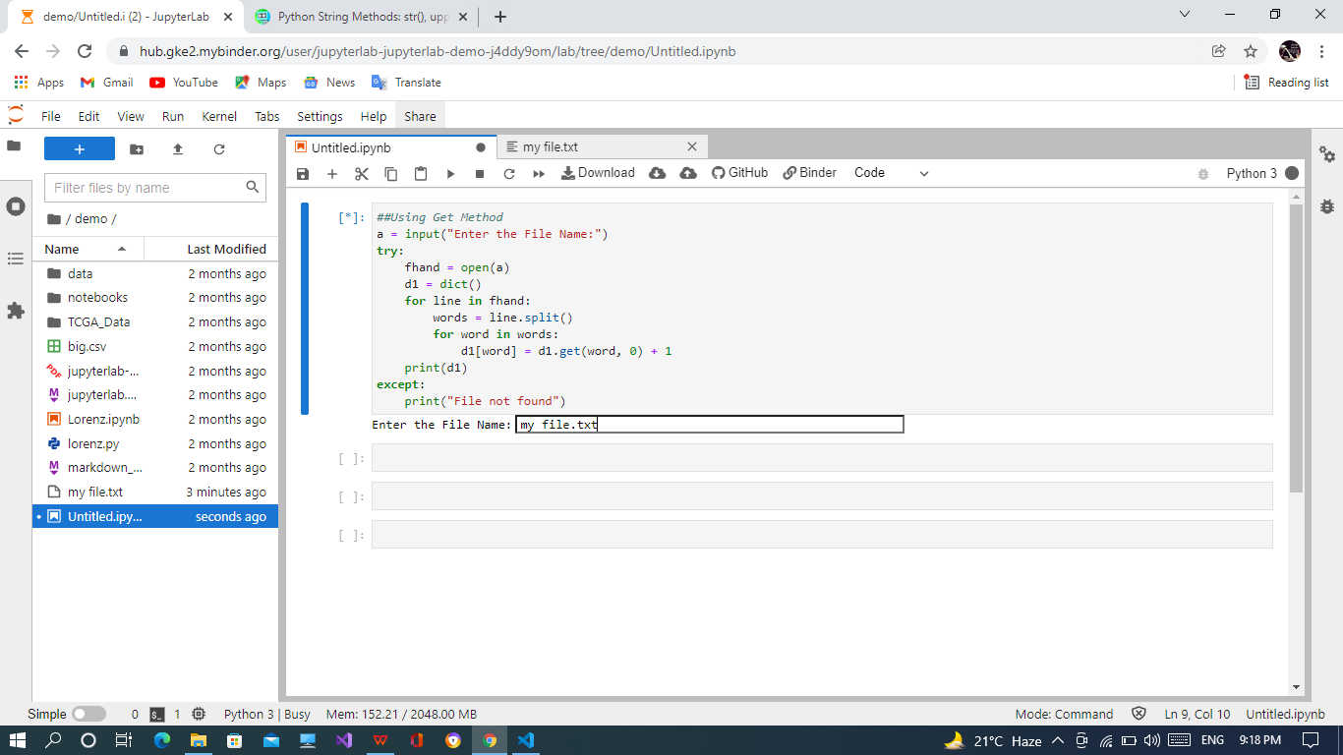

**Output of Code:**

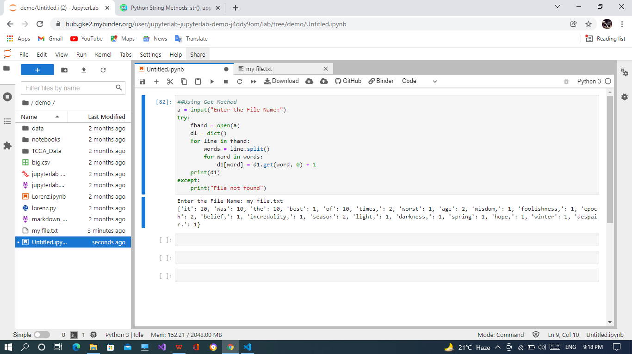

**TASK-2**

**TODO-LIST**

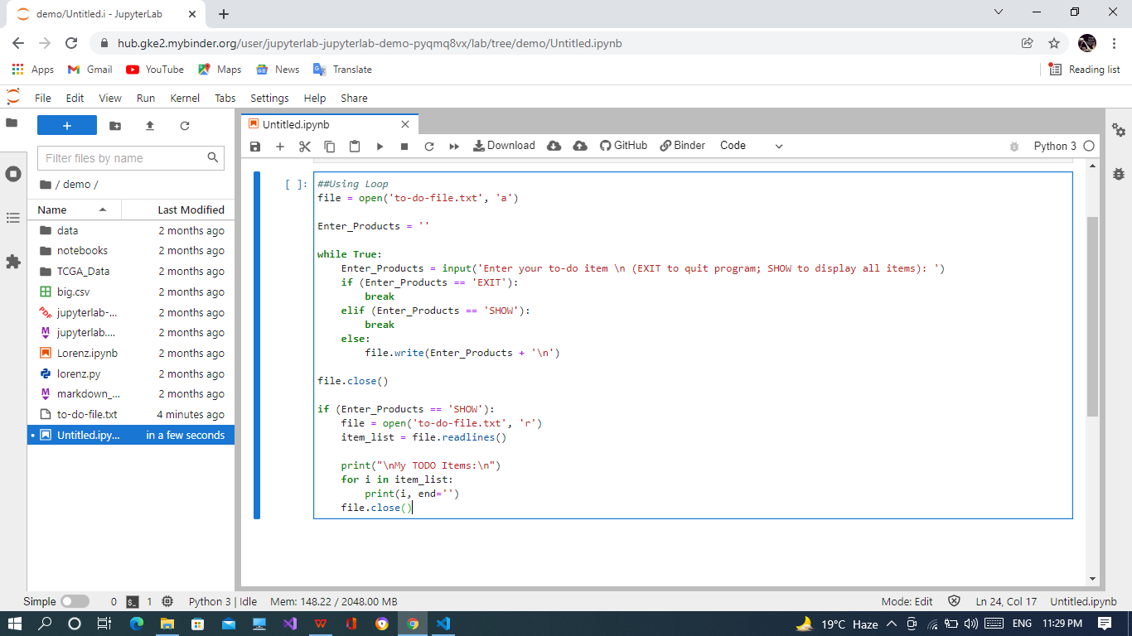

**Enter The LIST**

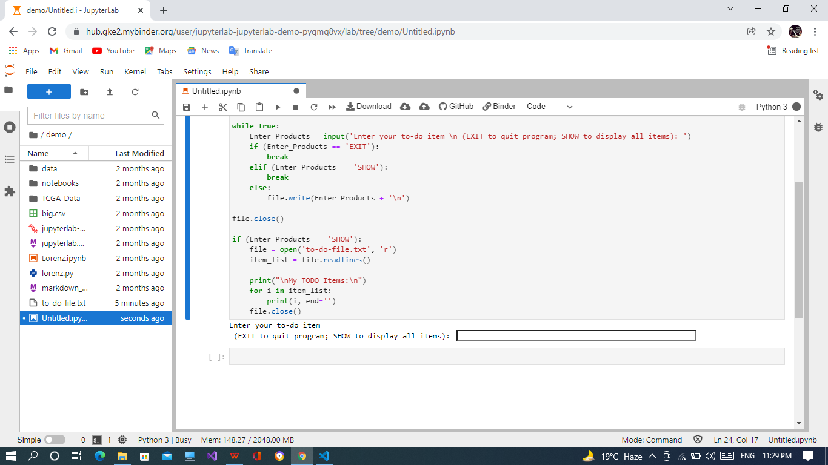

**Show TODO-LIST**

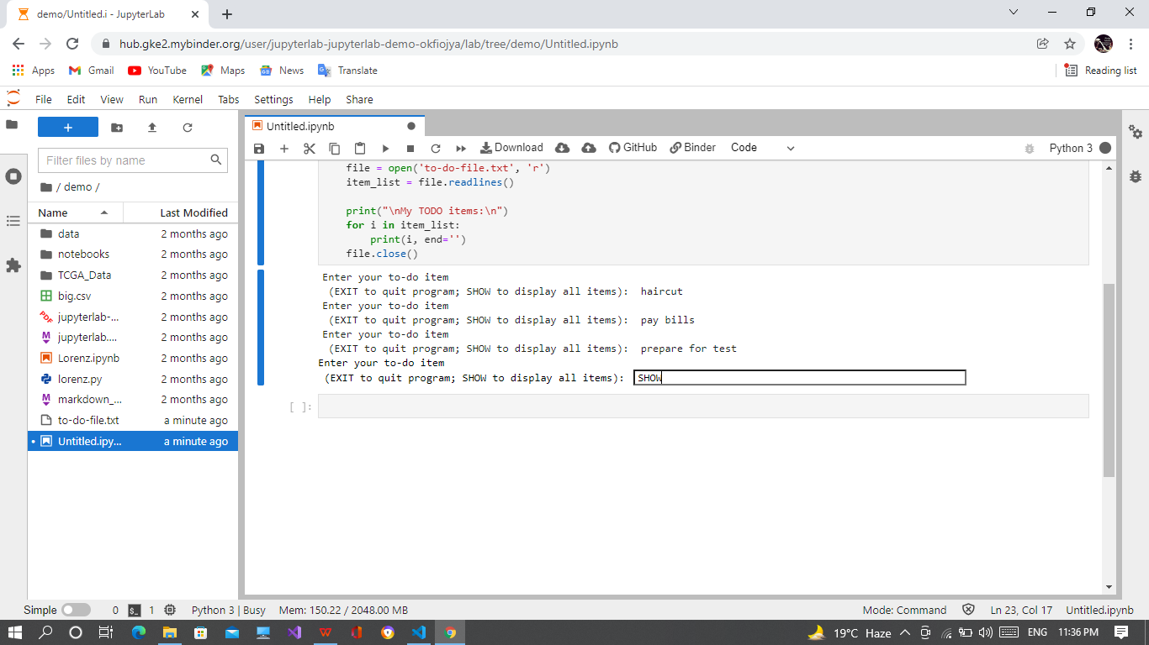

**Output TODO-LIST**

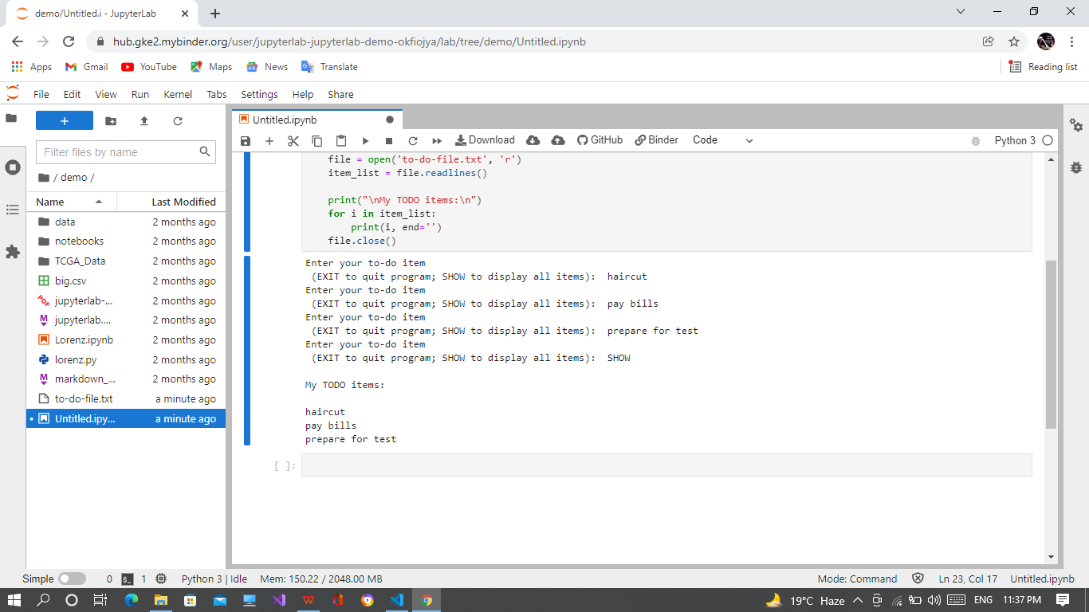

**Source Code:**

file = open('to-do-file.txt', 'a')

Enter_Products = ''

while True:

    Enter_Products = input('Enter your to-do item \n (EXIT to quit program; SHOW to display all items): ')

    if (Enter_Products == 'EXIT'):

        break

    elif (Enter_Products == 'SHOW'):

        break

    else:

        file.write(Enter_Products + '\n')

file.close()

if (Enter_Products == 'SHOW'):

    file = open('to-do-file.txt', 'r')

    item_list = file.readlines()

    print("\nMy TODO items:\n")

    for i in item_list:

        print(i, end='')

    file.close()